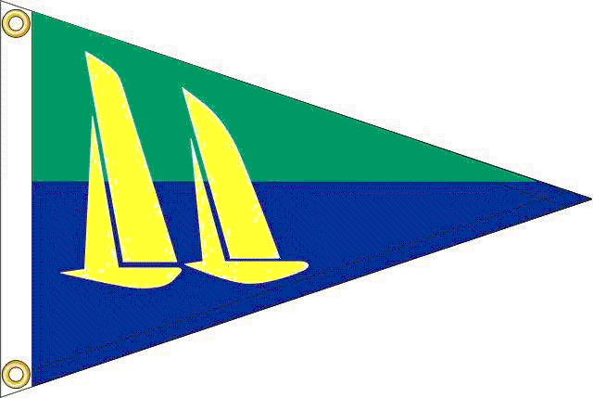

Kingston Sailing Club

presents the

2013 Spinnenweber Cup Regatta

Saturday & Sunday August 24 & 25
At the Hudson River Maritime Museum, home of KSC.

First signals 11AM Saturday & Sunday. At least two races Saturday & one Sunday.
Breakfast, on-site registration and skippers’ meeting from 9:00am Saturday. For Sailing Instructions, Courses & Registration form go to www.kingstonsailingclub.org.

Saturday: Barbecue party, beer & wine at the
Hudson River Maritime Museum – free to all skippers & crew.
Sunday: Snacks & awards ceremony.

A limited number of slips available at reduced charge of $1.00/foot for transient boats. Reserve early with your registration.

For more information contact
Commodore Ian Westergren; ian@spw.com or Regatta Chairman John Stephenson; jstephenson@hvc.rr.com.

